1(a). By running Portfolio Optimizer with the constraints that set cash holdings to be zero and the objective to maximize the Sharpe Ratio, the OCRA portfolio weights are as below:

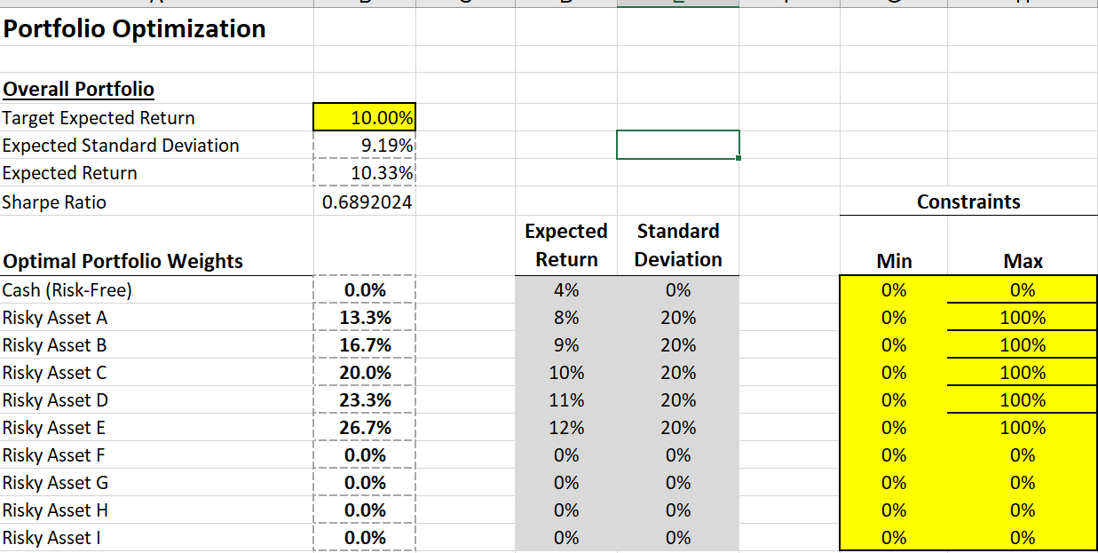

As for the dollar investment, Jane will invest $13,333 in A, $16,667 in B, $20,000 in C, $23,333 in D, $26,667 in E

(b) If she maintained the allocation:

How to discount the endowment? Need to forecast the price of stock and discount with risk free rate?

Her additional wealth through endowment = $100,000 \* $10 / (1+4%)^10 = $6755,64

effectively she invests $808,897 in A, $16,667 in B, $20,000 in C, $23,333 in D, $26,667 in E.

By restricting expected return equaling the target return (8.25%) and setting the target as minimizing expected standard deviation, the solver outputs solution as follows:

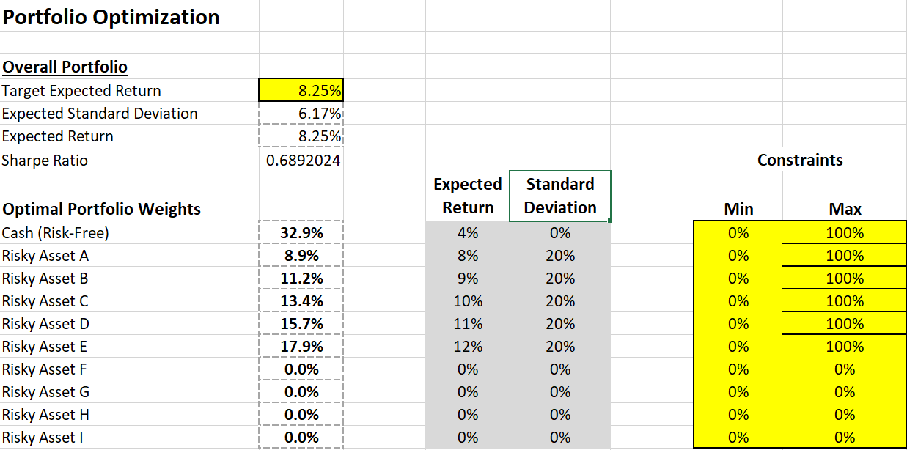

(Or equivalently, this result is the same as leveraging portfolio in 1(a) with risk-free asset to reach the target expected return)

Her total wealth is $675,564 + $100,000 = $775,564

Dollar investment in:

Risk-free: $775,564 \* 32.9% = $255,126

Risky Asset A: $775,564 \* 8.9% - $675,564 = -$606,172

Risky Asset B: $775,564 \* 11.2% = $86,740

Risky Asset C: $775.564 \* 13.4% = $104,087

Risky Asset D: $775.564 \* 15.7% = $121,436

Risky Asset E : $775.564 \* 17.9% = $138,784

121436

138784

Optimal dollar investment:

(c) She can enter forward market to settle a selling of the stock A from endowment at the time of her 35th birthday. But finding a counterparty & transaction cost might deter her from doing so.

2.

(a) OCRA portfolio is as follows, by setting cash holdings = 0 and maximize Sharpe Ratio:

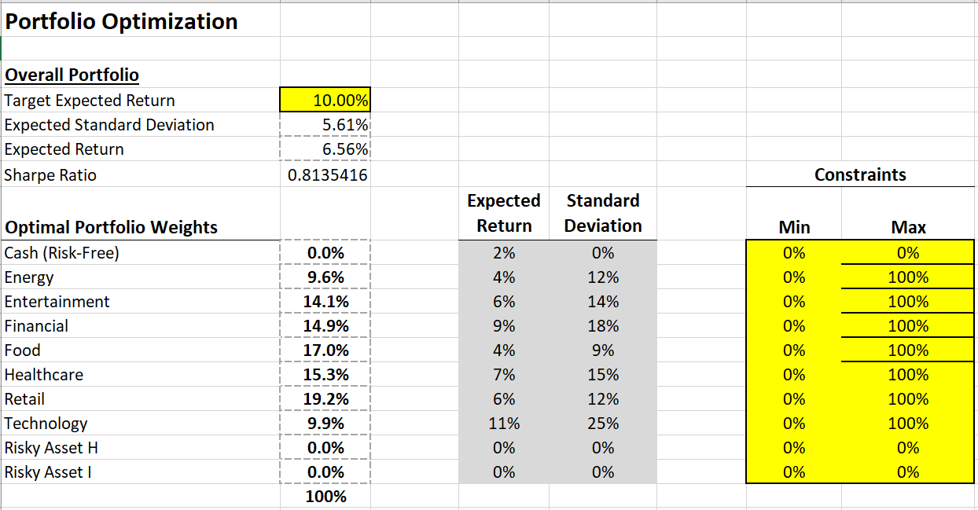

(b)

Jane has total wealth of $3 million. Her optimal investment is, by the portfolio optimizer:

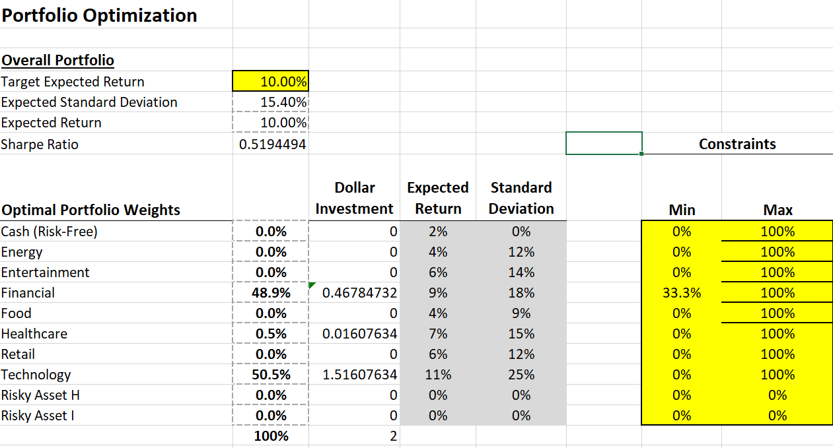

(*Dollar investments in Financial sector = $3m \* weight - $1m, while other sectors are simply $3m \* weights. Here I define dollar investment as the investment from savings.*)

(c) Using similar approach:

